Experiment 8

Create a simple cloud web application for student counselling system using any Cloud Service Provider to demonstrate SaaS with the fields of student name, age, address, phone, subjects studied, Year of passing, percentage of marks, domain interest, etc.

1.create user classes application form

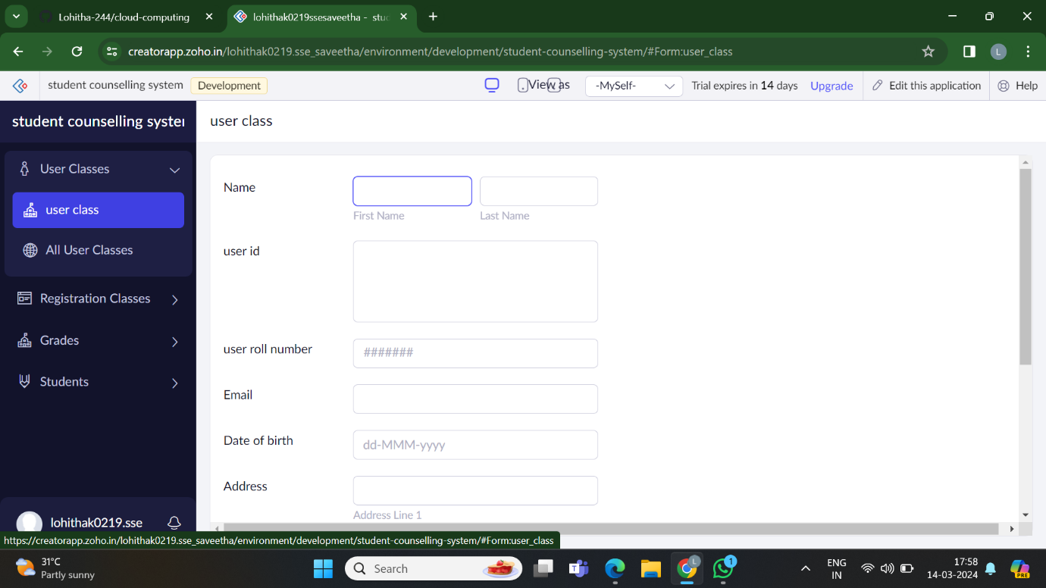

2.create student application form

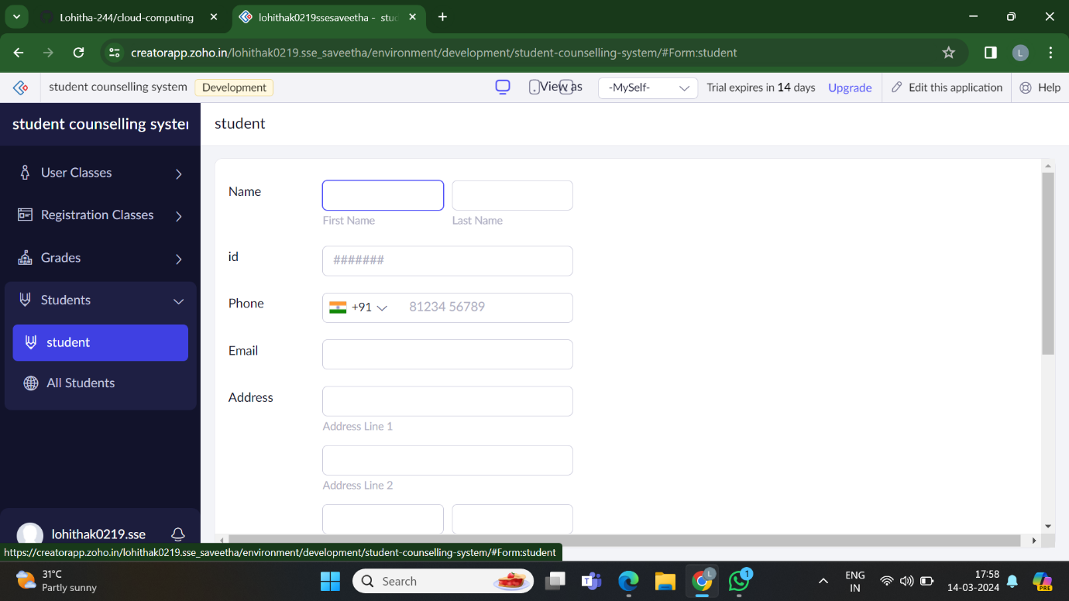

3.create grade application form

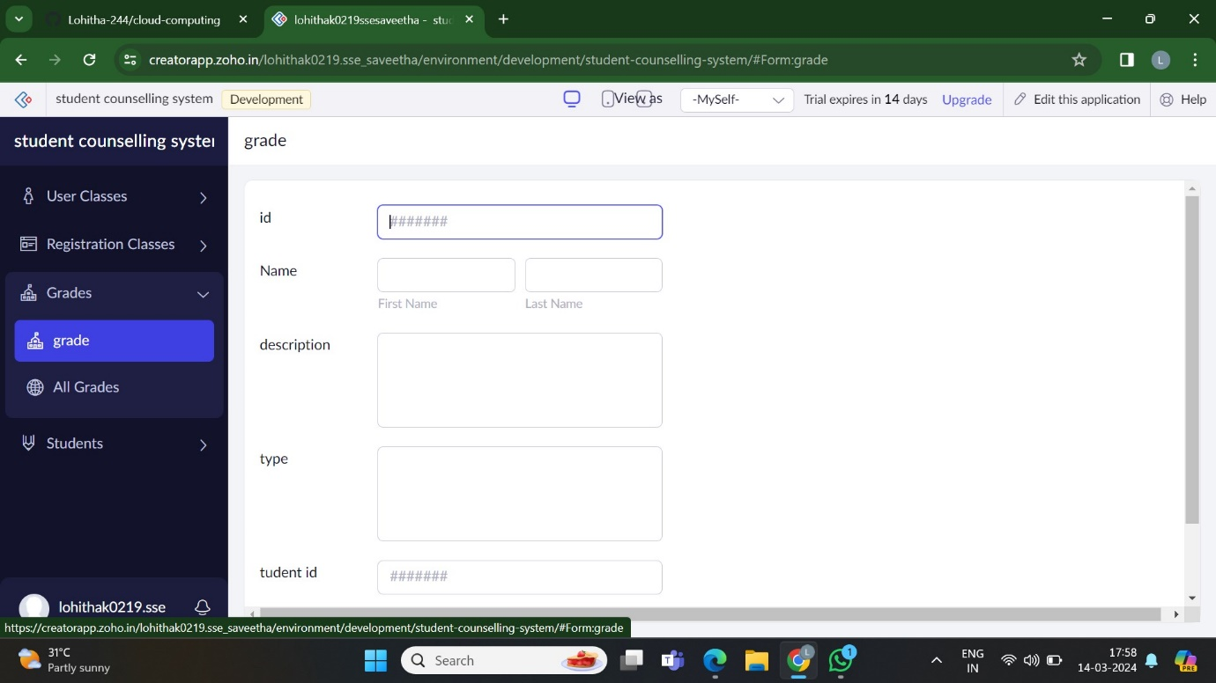

4.create registration class

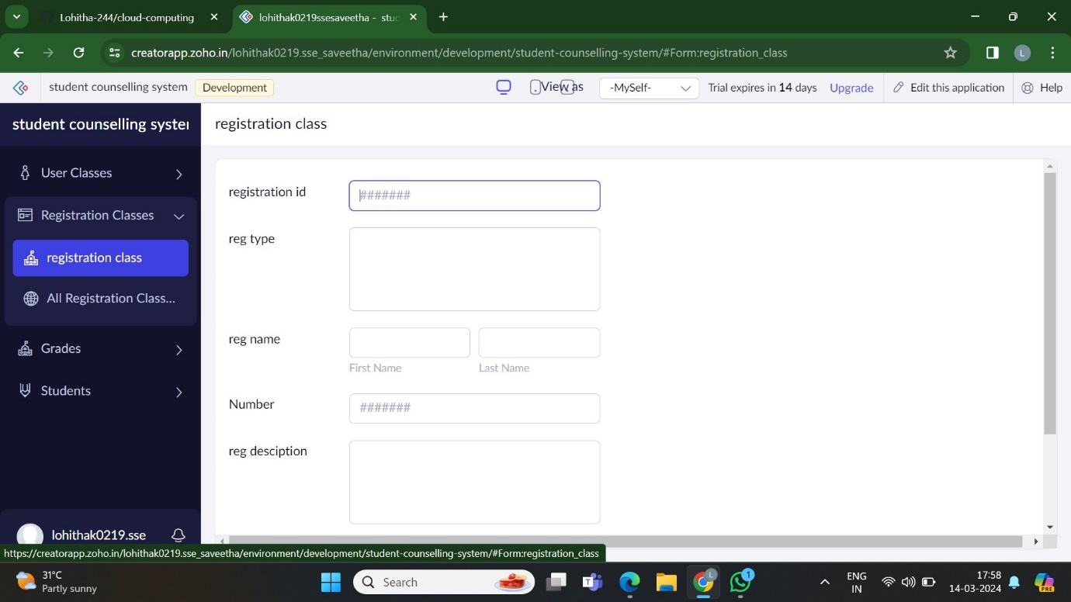

5.shows the result of all students

